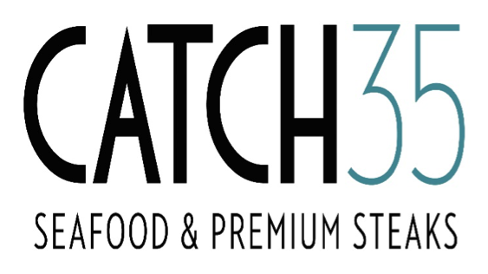

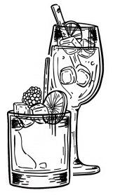

CAMPFIRE MANHATTAN I $14.00
High West Campfire Whiskey, Butterscotch Schnapps, Nueske’s
Bacon Garnish
-ADD HAND SMOKED CINNAMON STICK +$2
COCKTAILS
BLOSSOM I $12.00
Momo Kawa Sake, St. Germain, Poma Pomegranate, Orange Bitters, Brut
Cotton Candy

BLACK CHERRY MOJITO l $12.00
Bacardi Dragonberry, Sour Mix, Black Cherries, Soda Water

STRAWBERRY MOSCATO MARGARITA I $12.00
Patron Silver, Triple Sec, Strawberry Puree, Moscato, Salt rim

NAPERVILLE SOUR l $12.00
High West Double Rye, Fresh Lemon Juice, Simple Syrup, Topped with Malbec

KRAKEN MULE I $12.00
Kraken Dark Rum, Gosling’s Ginger Beer, Orange & Lime

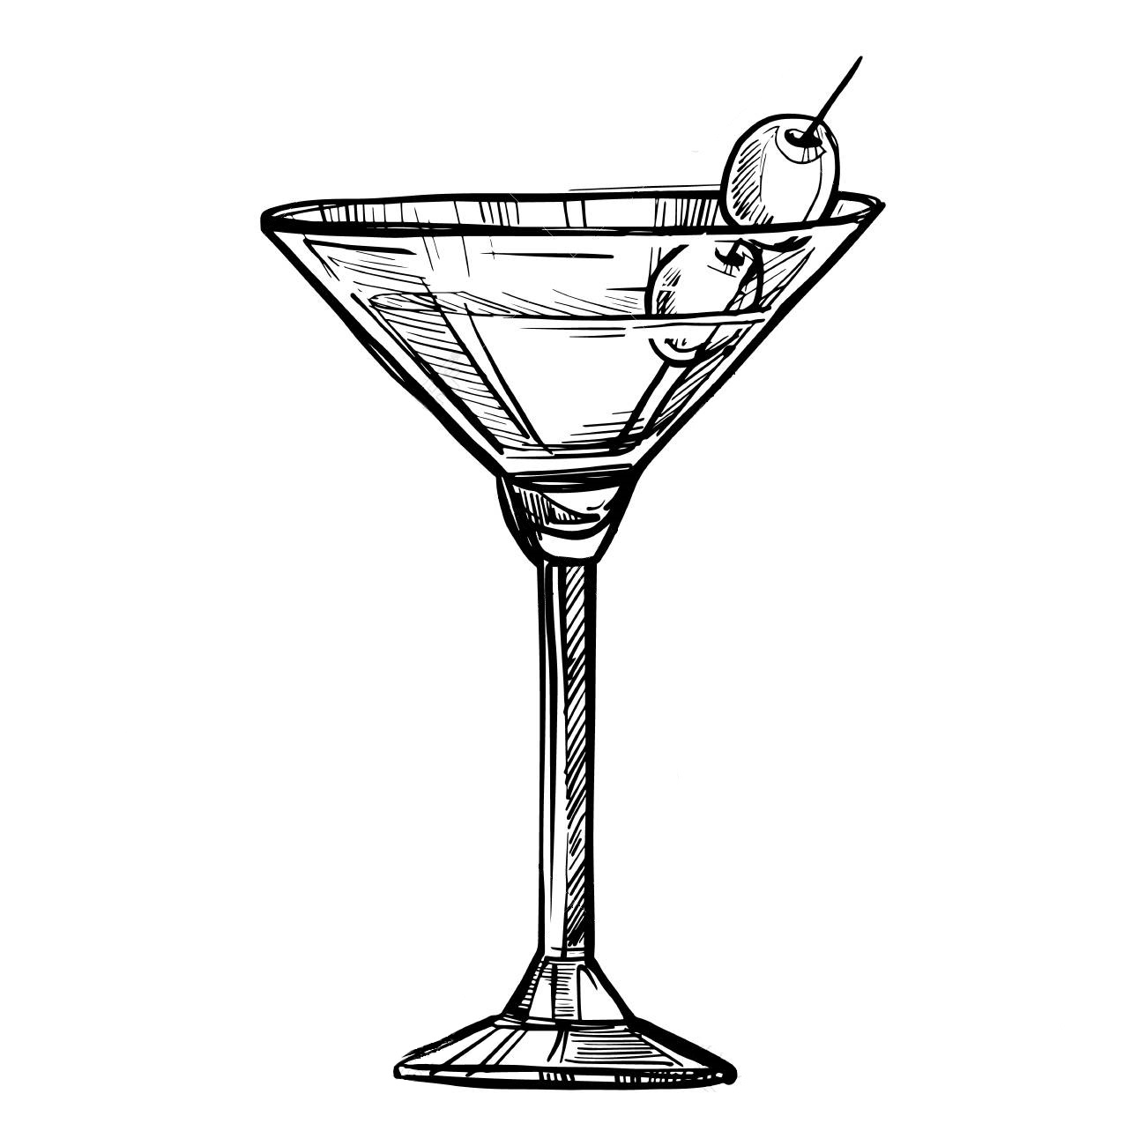

RASPBERRY LIMON I $12.00
Bacardi Limon, New Amsterdam Berry,
Sweet & Sour Mix, Chambord

KEY LIME MARTINI l $12.00
Vanilla Vodka, Rosas Lime Juice, Liquor 43, Crème
MARTINIS

ST. SOLEIL l $12.00
Hendrick’s Gin, St. Germaine Elder-Flower Liquor, Lime Juice

DRAGONFLY MARTINI l $12.00
Bacardi Dragon Berry Rum, Fresh Strawberry puree, Charles Lafitte Brut

CUCUMBER MANGO l $12.00
Hendrick’s Gin, St. Germaine, Mango Puree, Muddled Cucumber

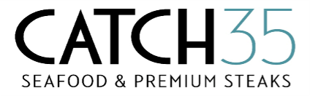

BEER SELECTION SELECTION

IMPORT BEER DOMESTIC BEER
Stella Artois: Euro Pale Ale – 7.25 Bud Light: Light Lager-5
Heineken: Light Lager – 6.25 Budweiser: Amber Lager-5
Corona: Pale Lager – 5 Coors Light: Light Lager-5
Modelo Especial: Lager – 5 Fat Tire: Belgian Style Ale-9
Guinness: Irish Dry Stout – 6 Miller Lite: Light Lager-5
***Buckler: NON-Alcoholic – 5

CRAFT BEER
Allagash White- Belgian Style Wheat Beer, abv 5.1%-7
Ballast Point- Sculpin, IPA, abv 7% – 6.25
Bells- Amber Ale, American Amber Ale, abv 5.8% - 7
Goose Island- Matilda, Belgian Style Pale Ale, abv 7% - 7
Half Acre-Daisy Cutter, Pale Ale, abv 5.2% - 7
Metropolitan- After-Burner Oktoberfest, Lager, abv 6.10%
North Coast-PranQster, Belgian Style Golden Ale, abv 7.6% – 7
Solemn Oath-Snaggletooth Bandana, American IPA, abv 6.5% - 7
SCOTCH-WHISKEY-COGNAC-PORT
Two Brothers-Domaine Dupage, French Country Ale, abv 5.9% - 7

SCOTCH
Johnny Walker Red – 10
Johnny Walker Black – 12
Johnny Walker Blue – 45
Macallan 12 year - 12
Macallan 18 year - 24
Glenlivet 12 year - 12
Glen Livet 18 year - 18
Talisker 10 year - 11
Balvenie 12 year - 10
Glenfiddich 12 year - 11

WHISKEY
High West Double Rye -12
Gentleman Jack – 12
Jack Daniels – 10
Jameson – 10
Crown Royal – 10
Black Bush – 9

COGNACS
Courvoisier VS – 9
Hennessy VS – 10
Courvoisier VSOP – 11
Remy Martin VSOP – 11
Remy Martin XO – 25

BOURBON
Baker’s – 11
Makers Mark – 11
Makers Mark “46” – 12
Basil Hayden – 11
Bulleit – 11
Knob Creek – 12
Templeton Rye – 11
High West Campfire - 12
Woodford Reserve - 11
LOUIS XIII
Half Ounce –100
Full Ounce –200
Two (2) Ounce – 400

PORT
Dry Sack-Medium – 7
Taylor 20 Tawny – 18
Warres Warrior – 12
Warres Otima 10 Year – 10
Warres LBV 2004 – 16

